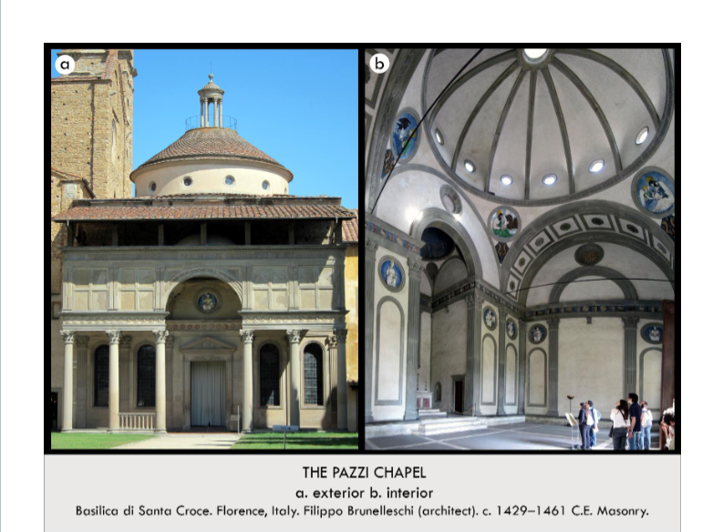

| **Form:** very simple and unlike the gothic churches. combination of serene stone and plaster(white), -nice contrast of dark and light materials mathematically harmonious, regularly proportioned, and monochrome. Makes use of Pietra Serena Stone -- used to create spacial divisions, A space with perfect geometry, shapes all over  **Function:**As a palace of worship and a Christian church. A chapter house for the monks in the adjacent Franciscan church of Santa Croce ( A gathering place for monks.)/ a physical representation of the Pazzi family's power, wealth, piety, generosity, and status  **Content:** contains a chapel behind the altar for the burial of the Pazzi family.  renaissance because:-dome—with pandenta and -coffered elements  references to Rome—corinthian capitals, was a square with a circle inside—complete harmonious proportions  Classical arches, serial and centrally planned.  Corinthian columns, Fluted pilasters, Pendentives with roundels (each roundel is made of clay and is glazed and represents the four Evangelists) Small barrel vaults, A dome with a halo of windows (Hagia Sophia) and an oculus (Pantheon) (dominates the space-- the center of the chapel, the windows + oculus allow for divine light to enter the space), The space feels very constructed, ordered, designed, and rational.  **Context:** Commissioned by the Pazzi family(powerful family). Per commission from the family it was Designed by Filippo Brunelleschi in 1423 and completed after his death in 1461 with the possible additions by others. Has a classical style. One of the first independent renaissance buildings conceived as a central-plan structure emphasizing the vault over a rectangular space. reminiscent of the Pantheon's floorplan, Based on the models of ancient Roman temples = a revival of Greek & Roman ideals, a piece that's representative of the Early Renaissance  **Compare:** current day white house. Any simple centrally planned building  **67**  Early Europe & Colonial Americas |
| --- |

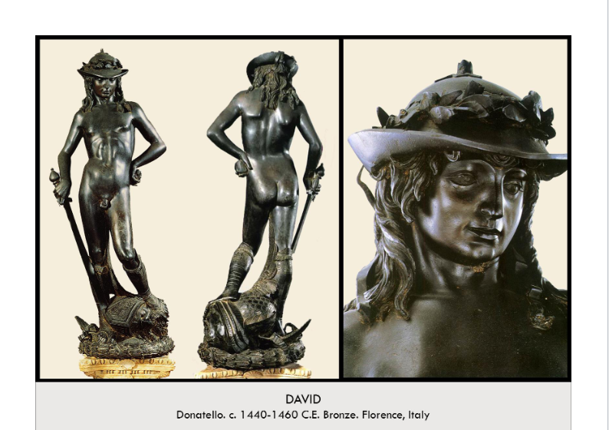

| **Form:** 5 feet tall, Material: bronze. Shows naturalism-accurate proportional body and stylized.  **Function:**For private viewing from the Medici family. represent the story of David and Goliath, tell Christian follows that with challenges, Gods might will help you= You will gain wisdom and strength from God, People of Florence identified ed with David: believed that they defeated their enemy (the Duke of Milan) with the help of God  **Content:** David is shown in his youth, a shepherd boy, after his defeat of the giant Goliath he calmly stands with his foot on the goliath's head, head down in humility, wearing a foppish, renaissance hat symbolizing his status as a poet, the composer of the psalm. David has a contrapposto stance.  intimate, beautiful and vulnerable: warm tones of the bronze and small size: feel a closer connection, sensuality which contradicts that this is an old testament subject/ not a biblical representation , Gruesome head vs with beauty and sensuality of young David= Donatello depicted David’s innocence (instead of more masculine and frightening) in such a gruesome event, the bronze: smooth the seams and the surface and to cut in details (like the hair): just like Greeks/ Romans, intimacy: the nudity, the expression of the face, and the stance of the body, Free-standing: detached from the architecture gives it the freedom to move in the world, show expression, and communicate with you + contraposto= humanistic  **Context:** commissioned by the Medici family for private viewing in their palace. David becomes the symbol of the family and the Florence republic, a small power desiring freedom and independence from Rome. Shows a shift of the times and a focus on humanism instead of a center around the church=private art.  The first freestanding nude male sculpture since antiquity/ roman times= was thought of as inappropriate by the church. Donatello: studying ancient Roman art: displays classical knowledge of contrapposto + large-scale bronze casting of the ancient world, Donatello displays ancient Greek and Roman art of the naked human body, Middle ages: a period when the focus was on God and the soul and didn’t create nude art  **Compare:**  **69**  Early Europe & Colonial Americas |
| --- |

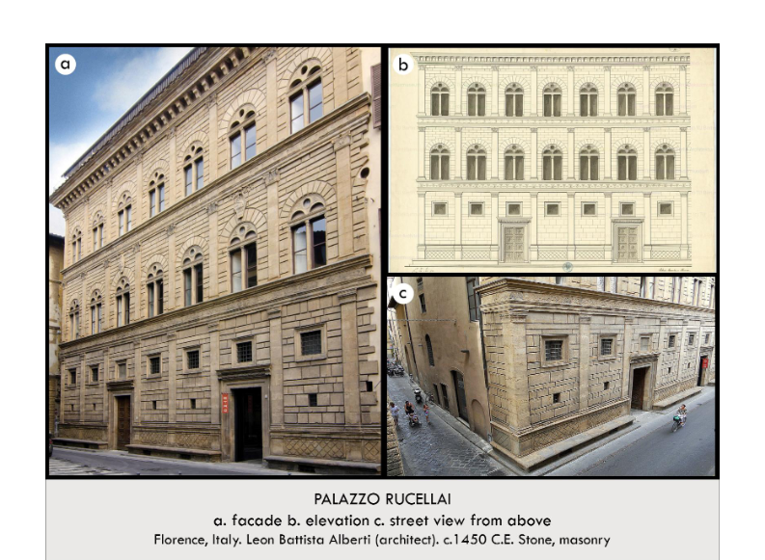

| **Form:** Made of sandstone there was the main entrance and office and guardroom and a storeroom. Created in an effort to emphasize **measure** & **harmony,** Filled with “geometric grace” -- intellectual & delicate, *All about horizontality —The higher the floor = the more intricate & fancy it became (+ smaller stones were used as you moved up)*  The building has four floors: 4th floor: the servant quarters (it was designed to be hidden), 3rd floor: the family's apartment  2nd floor: the guest rooms and area, 1st floor: the Rucellai family's center of business  **Function:** created as a domestic space, for living and business/ physical representation of the family's wealth, status, power, and importance.  **Content:** A flat calm mathematically coherent and classically-derived grid-like design of the three stores linked by vertical pollsters and horizontal, Nearly every piece of the Palazzo's design is pulled from ancient Greek & Roman architectural ideals, Pilasters, Capitols(Corinthian, Ionic,Tuscan),Rounded Arches, Entablature with friezes Included several features for design rather than actual support, 1st Floor = grounds the building( HEAVY, Surrounded by benches, Has:Cross-hatching, Large blocks of stone, Post-&-Lintel portals, Rectangular windows, All straight lines.  **Context:** family home of the Rucellai family. Commissioned by a family of merchants, bankers, and art patrons as a palatial family business space and private residence designed by Leon Battista Alberti in 1466. Made of classic architecture and classically no gothic, very down to earth and real. Created simply at the bottom. At the time, palaces were viewed as if they were created for the city's good and thus, brought Florence much civic pride.The Palazzo was never actually finished -- only 3/4ths of the original plan was constructed, Partly based on the Medici Palace (and it’s three facade design) (The Medici Palace was much heavier though and more fortress-esque)  **Compare:** house of the vettii (pompi)  **70**  Early Europe & Colonial Americas |
| --- |

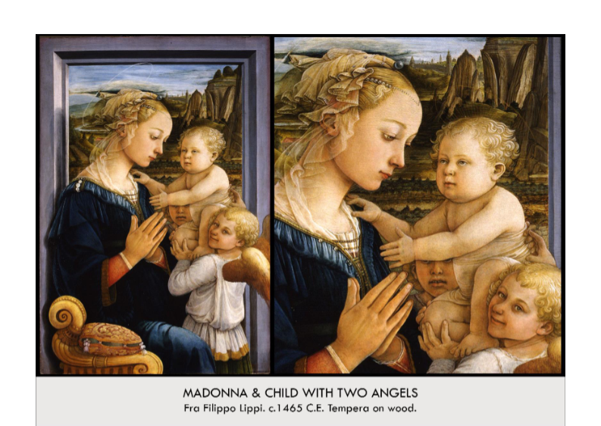

| **Form:** Tempera on wood, **meant to make godly people seem relatable** -Madonna is brought forward, "Her shadow is on the frame, she is in front of it, like an actor at the front of a stage", humanist, **realistic**, **naturalism** -angel in the background has half of his face covered by, slightly somber. landscape in background has, atmospheric perspective, earthly =humanism, idea of sensuality- beauty , importance to decorative components - translucent drapery on Mary's head, also important to Lippi's student - Botticelli  **Function:**Created for private devotion/exhibition, Medici family paid for this art to show piety, to show wealth (this guy is a very famous artist), Decorative, to be reminded of Christ’s story, wanted a humanist image to be able to relate to Mary and Christ, humanity / realistic    **Content:** Picture Mary, Jesus, and two angles. The virgin is sitting in an opulent chair in a Florentine home. Sits at a slight angle casting a shadow on the window frame behind her which looks out on a landscape featuring actual sights in the Arno river valley pearls, in the headdress and in the pillow, are symbols of the immaculate conception. Madonna is depicted as a sensuous, worldly young woman. She is idealized and beautiful. Their expressions are not pious but naturalistic and mundane. very simple halos, Mary is youthful and beautiful, sculpted fac, fair, blond hair, delicate, has emotion, The angels, look playful, angel in the foreground is smiling at the audience, healthy, cherub-like. Christ, small, "chubby" , fair, baby like  **Context:** unknown commission ( possibly by Giovanni de Medici as a gift to the king of Naples)- shows the humanism of the times. Shows these religious figures as mundane people that exist among the times and the people on the earth instead of on heaven. Painted by Fra Filippo Lippi. Lots of money in Florence during this time, growing middle and upper class of merchants and bankers, lots of money means more indulgences , "Florence saw itself as the ideal city state, a place where the freedom of the individual was guaranteed, and where many citizens had the right to participate in the government"  **Compare:**  **71**  Early Europe & Colonial Americas |
| --- |

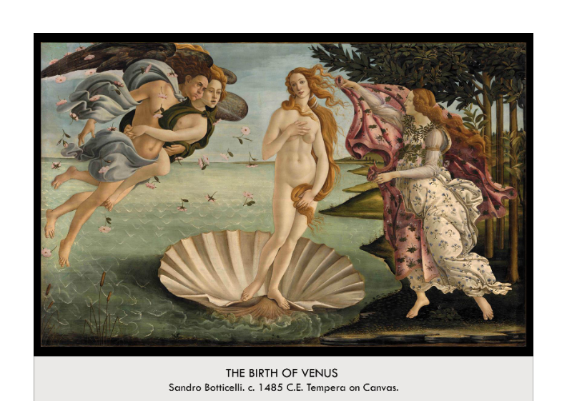

| **Form:**  Created by Botticelli, She stands almost casually (not contrapposto), Flexible, skeletal structure (her body), Lots of folds and lines that intersect with one another (waves, seashell, clothing) — Indicative of movement --> sourced at the two air spirits creating wind on the far left, She stands almost casually (not contrapposto)  **Function:** Decoration/beauty, Mythological and educational, Artist reveled in his own creation    **Content:** It Shows Venus (Roman goddess of love and romance), blowing in from the ocean. As she is born. Standing atop a white shell, Golden hair, pale skin, entirely nude (but covering her lower body to incite modesty), Accompanied by an attendant with a cloth to cover her (far right) Tempura- egg yolk and pigment. - she is one of the tightens that’s part of the Parthenon. and there are roses surrounding the image. And ancient Rome goddess. Zefer and close on the left and handmaiden on the left. covering venus with a clock. Zephyr and Aura, wind sprites, blowing wind from the far left  **Context:**  Iconic painting, unknown for 300 years, discovered by Botticelli, this is one of the paintings that survived from being born, the greatest depiction of femininity. Crated for the Medachi. Images of nude women were only tolerated in two contexts: educational or mythological, This was the latter, Painting her naked was a “radical statement”, Not in a Christian context, heading straight into the Renaissance movement  **Compare:**  **72**  Early Europe & Colonial Americas |
| --- |

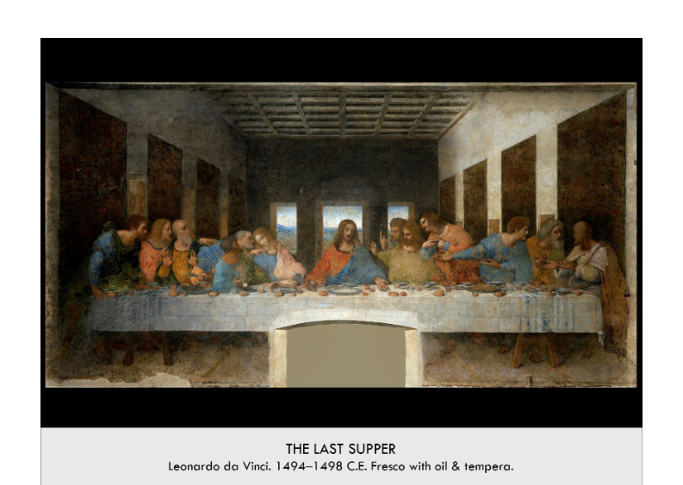

| **Form:** Oil and tempura was an experimental combo- Used lead white as a base instead of traditional wet plaster to achieve more brilliant colors, but the paint never adhered to the wall and began immediately deteriorating= terrible condition. Perfect perspective is achieved at Christ’s level using linear perspective, This view is 15 feet in the air, Strong sense of depth conveyed, Vanishing point right behind Christ’s head draws the viewer's eye to this central figure, Christ’s body forms an equilateral triangle,Very unified composition (it is intentional, mathematical, and precise)  Faces are individualized and figures are realistic with accurate proportions and light and shadow (chiaroscuro), Use sfumato technique, Great emotion, gesture, action (clamour and reaction of the figures), and interaction between figures  **Function:** Piece of virtual reality, a religious commission for a wall, illustration of the bible story. Monks would eat silently while looking at this painting.-- Used to teach and inspire contemplation about this pivotal moment in the religion  Shows unity between the earthly, mortal world and the eternal and divine but also shows the chaos and flaws of humanity and greatness of the divine  **Content:** The 12 apostles sit at a long table placed parallel to the picture plane in a simple, spacious room and react to Christ saying, “one of you will betray me” during seder at Passover (christ’s mouth is still open)- **The apostles have highly** emotional reactions, In the center, Jesus appears isolated and composed while his apostles freak out around him, showing his divinity and ethereal nature. He is reaching for the bread and wine, the sacrament of communion  4 groupings of figures create a clustered, chaotic sense to the scene (Judas to the right of Christ has head down in shame and holds the bag of silver. He is reaching for the same bowl as Christ, Peter is rushing to Jesus, pushing Judas back in need of knowing the betrayer, and he is holding a knife ready to defend Jesus foreshadowing, John closes his eyes)  Through windows is a lush green landscape symbolizing heaven, which frames JC showing his divinity over all the others, 3 windows, 4 groups of 3 apostles, Christ body forms a triangle = holy trinity and divinity, Painted on the side of the refectory of Santa Maria delle Grazie in Milan.  **Context:** Wanted the painting to look like it was part of the room. Changed the view of this scene. Created for a religious commission. Was completely recreated and there is not much left of the original painting. Known as Leonardo da Vinci's best/most famous work. During the high renaissance period. Da Vinci, born in Florence, was a painter, sculptor, engineer, architect, and scientist, he Trained with the prestigious Andrea del Verrocchio, High renaissance (rebirth of classical ideal of beauty, use of shading, naturalism, and humanism), Centralized in Rome, art was commissioned by popes, Missing halo distinguishers like early renaissance, but it is obviously the last supper because of da Vinci’s complete mastery of skill, Fascination with the body to show beauty of nature and convey the soul, Narrative style of painting common where the body and emotion reflects the mind. Idealized geometry of Jesus is in line with the Renaissance’s rediscovery of Neoplatonism (humanist revival combining Greek philosophy with Christian theology)- Plato believed that the mortal realm was imperfect, and the divine can be seen in heavenly, geometric perfection. Da vinci practiced with live models, and therefore had a deep understanding of the observable world which is reflected in the highly individualized and proportionally correct apostles  Cross Cultural Connections  **Compare:** Mona Lisa  **73**  Early Europe & Colonial Americas |
| --- |

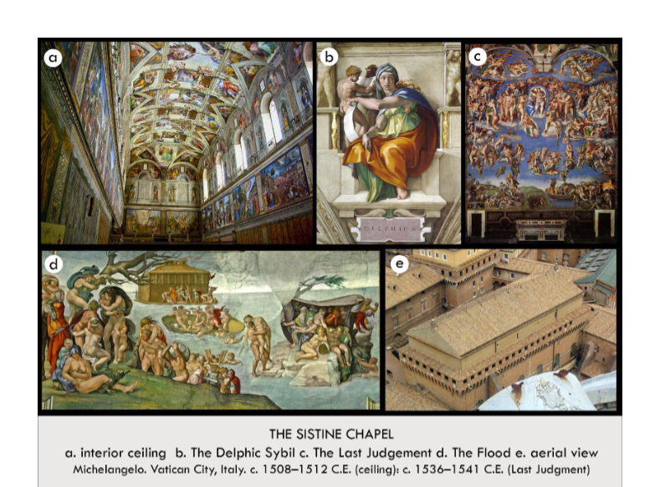

| **Form:** A—-The ceiling is a slight vault, created the ceiling on a flat surface, shows pure renaissance area and the aspects of renaissance art are very apparent.  **Function:** decoration for a chapel/ religious are/to depict a scene **B**: the sibyls were said to be future-seers of pagan times who saw the coming of Christ, validates the Christian faith because the coming of Christ was foretold long before Jesus was even born, shows a theme of foretelling present in Christian artwork since the Middle Ages; sibyls foretold the coming of Christ, the Old Testament foretold the coming of the New Testament, Mary foretold the death of her son  **Content:** A—-The ceiling consists of stories from the book of genesis. Created grisaille figures which showed his experience with sculpture, showed the human body and showed naked bodies very beautifully and realistically. Shows the prophets who are writing, with an angle behind them whispering in their ears. There was also the Delphic civil, who were ancient Greeks. Painted the genesis and the first 7 days, light from dark, the sun itself, the water and the land, the creation of Adam, the creation of Eve and the temptation, and the expulsion and sacrifice of Noah.  B—- Elbow coming forward, hair coming forward with her hood, beautiful coloring, beautiful curvature of the body and angle behind her. her body has a circular composition , signifies grace, balance, and harmony of proportion, she has a "sculptural weight"--looks as though she is actually coming out of the walls due to the painted contour (contrapposto) of her skin and muscle , she has idealized anatomy--by the way her muscles are sculpted, she looks as, though she has incredible strength, yet she also possesses a sense of calm elegance (sprezzatura: a deceptive ease), shows close attention to human anatomy.  D—- The flood, one of the early panels before he shows creation, is a crowded composition that diverges from the age, not doing clarity and it has no center of interest, meant to convey the moment in the book of Noah, painting of the doomed, chaotic moment and shows this with twisted bodies.  C—- Crist in the last judgment angle at the top holding the cross, and beneath is Jesus who is portrayed as apollos- seen as the sun is behind him. His profits are spinning around the sun. coding to show that the sun is the center of the universe. Jesus lifts the dead people’s souls/bodies up, we see Adam and Peter, who is handing his keys back, and it is very pessimistic. Adds a self-portrait. Taken the holiest figures and painted the naked portrait of someone who criticized him while painting in hell.  **Context:** The ceiling was painted by Michelangelo who did not want to paint it but was required if he wanted another commission, Michelangelo was mainly a sculptor and not a painter. He was the only one to paint the ceiling he taught himself to paint from doing the ceiling and shows much change through his art, which went from small and messy to larger and clean.  chapel= Michelangelo began work on the frescoes in 1508 for Pope Julian  he continued work on it for 4 years, but took a break in 1510, and the frescoes painted after this time are palpably different--compare the complex narrative of The Deluge, which uses smaller figures, to the more idealized, monumental figures in God creates Adam  B: painted after Michelangelo took his break in 1510, so they show his new style of monumentality, some believe that all the sibyls are modeled after the ancient sculpture the *Belvedere Torso*  **Compare:**  **75**  Early Europe & Colonial Americas |
| --- |

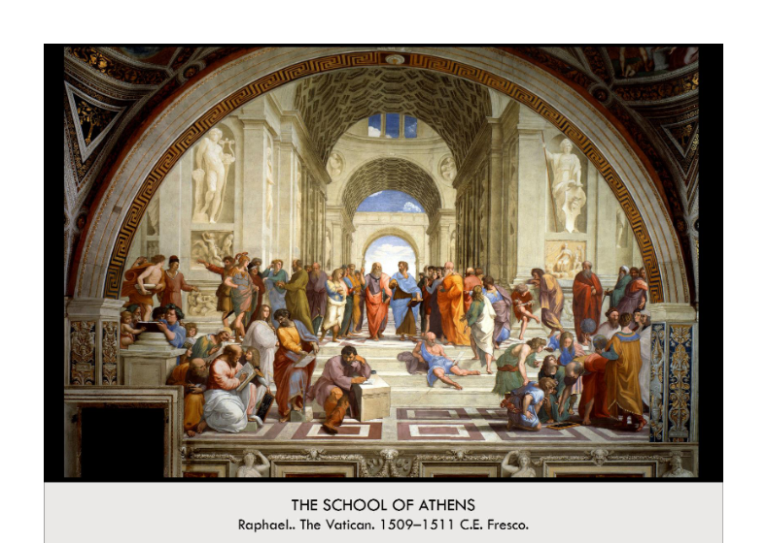

| **Form:** Painting on a wall, fresco (and preliminary sketches with charcoal powder), Location: Stanza della Segnatura, the Vatican, Rome, Italy. The figure in the foreground of School of Athens is writing on a marble block that’s tilted at an angle towards the viewer. Because of this angle, it can’t depend on the central vanishing point, which was determined using one-point perspective. Therefore, Raphael added a left vanishing point and a right vanishing point, both on the same Horizon line with the central point (which follows the rules of perspective.) The writing block uses these two vanishing points, = viewer is not perpendicular or parallel to it. All of the other figures and objects rely on one of the two perspective points. Raphael groups people on the left and right, leaving the middle space relatively empty. = balance the linear perspective at the bottom of the painting to balance the sharp orthogonals at the top of the painting. Just as in da Vinci’s The Last Supper, Raphael divided the figures into groups, but they are individual, and move fluidly amongst one another. The architecture uses linear perspective, most visibly in the orthogonals in the pavement and in the receding cornices (moulding around the wall of a room just below the ceiling.), Raphael used Greek models for calculating the proportions, which were later adopted by the Romans and then Renaissance humanists.  **Function:**As decoration for the popes’ library. The four frescoes Raphael created for Pope Julius’s Stanza della Segnatura, or library, were arranged to represent the classical topic of the books on the shelves below. Raphael demonstrated Renaissance perfection on a massive scale, and his work reminds us of the harmonious proportions and idealized figures of antiquity. His School of Athens is also a tribute to the wisdom of the ancient philosophers, and a prayer that their knowledge will pass onto the holy Pope, and the artists and citizens of Italy.  **Content:** Painting an image of learning, and ancient asthenia academy, shown in one-point perspective and ancient roman basilica in grisaille sculpture- painting technique. People include Alexander the Great, Aristotle who is gesturing at the ground, and Leonardo playing Play Doh gesturing up to the heavens. Pythagoras , Raphael, zoroaster. All of the great thinkers and philosophers of antiquity are gathered here in this classical space, surrounded by Roman architecture. Plato and Aristotle are the central figures the viewer’s eye is drawn to them as they engage in discussion and stride forward towards the us. Plato was Aristotle’s teacher. Plato focused on the ethereal and theoretical, so he points upwards to the sky, and wears red and purple robes, which symbolize fire and air. On the other hand, Aristotle focused on the physical and observable, so he gestures towards the ground, and wears blue and brown robes, which symbolize water and earth. On Plato’s side, the left side, there are the philosophers who focused on the theoretical, ethereal issues of philosophy.= Pythagoras, On the right side, Aristotle’s side, there are the philosophers, like Euclid, who focused on the physical and concrete. He used coffered barrel vaults, pilasters.there are classical sculptures of Apollo, god of Sun, Music, and poetry. can see Athena, god of war and wisdom. Raphael’s work opposed the Medieval idea of an authority passing down knowledge. He glorified the history and sharing of knowledge, and emphasized his subjects’ grace and wisdom. The coffered ceiling, which uses the rules of perspective, is a tribute to man’s dominance over nature. On the stairs is Diogenes, and writing on the tilted marble block is Heraclitus. Heraclitus has Michelangelo’s features, who was known for his lonely and impersonable affect. Heraclitus was added after Raphael had completed the frescoe. He includes himself  **Context:** Painted for the pope’s library, one of the roomes in the Vatican palace, painting this at the same time as Michelangelo was painting the Sistine ceiling . This work was created during the High Renaissance in the Stanza della Segnatura. Rome and Italy as a whole were still experiencing much cultural growth and prosperity, just years before the Protestant Reformation would shake the vitality of the Italian Renaissance and its artists. The Reformation brought about an uncertainty about salvation. However, Raphael’s School of Athens were created just before the Reformation struck, and testify to greatness of pagan wisdom as well as the “vastness and variety” of the papal library. The four walls in the Stanza della Segnatura showcase the four branches of human knowledge: Philosophy, Theology, Poetry, and Justice. Raphael’s ceiling, which is modeled after Michelangelo’s Sistine Chapel ceiling, contains four allegorical figures representing the four branches of knowledge. Religion, or theology, was seen as an [philosophy’s equal at this time, which is important to remember with the Protestant Reformation just around the corner. Raphael drew his inspiration for the impressive architecture in his School of Athens from the surrounding Roman ruins, such as the Baths of Caracalla, and the Basilica of Manutius and Constantine.  **Compare:**  **76**  Early Europe & Colonial Americas |
| --- |

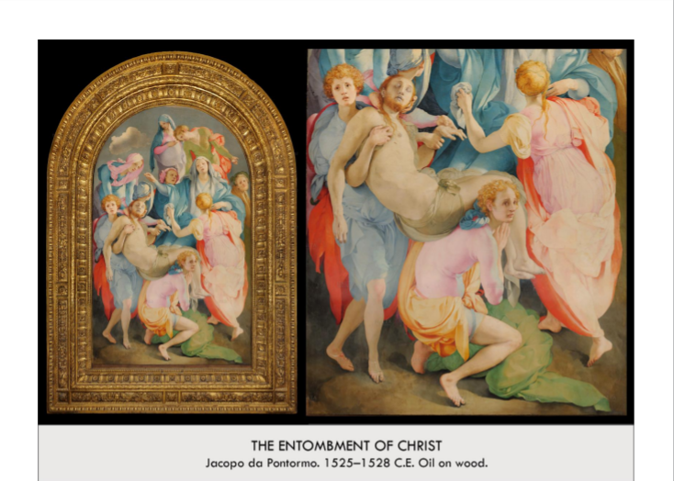

| **Form:** Very beautiful, in its original frame in its original chapel. shows/ depicts Mannerism aspects, it is grounded and dissonant, the figures are elongated . Painted oil on wood, In a church to the right of the entrance, above the altar, in the Capponi Chapel in Florence, Early mannerist style (see below), This is important because the chapel is a cubical, very logical space, that is very much in the Renaissance style and there are Renaissance frescos right next to it that show in annunciation  **The Mannerist style:-** Term used to describe the art that directly succeeded the Renaissance and preceded the baroque, Over-elaborate distortion and elongated figures, Imbalance, Very different than the perfection of the Renaissance, Response to the Protestant reformation  **Function:**Decoration for a chapel. Altar piece, Aestheticizes the well-known scene, the Deposition  **Content:** See the self portrait of the artist on the right. People wearing pink jumpsuits, not quite natural and give a strange distorted sense of color. Has painted the Mary and Jesus of Michelangelo statue Pieta in the same pose, and created the moment after. Where they are taking Jesus away. Mournful, The fresco beside it shows the beginning of Christ’s live (annunciation) and this shows the ending, Just figures, not much land, packed with people—This is very mannerist and the completely opposite of the Renaissance, There is no depiction of a cross so we are not sure as to whether it is the deposition or the entombment, Unnatural body position of the figure in the left foreground, Abandons the high Renaissance pyramid balance, No place for our eye to rest, Constant movement, Figures have no weight to their body, Over exaggerated emotions— Not emotions of a person, rather symbols of emotions (like masks)  **Context:** During the 16th century. In the Capponi Chapel of Santa Felicita, Florence., Frescos clearly in early mannerist style, but chapel is a cubic space that was designed by Brunelleschi in early Renaissance style. In pendentives, roundels showing 4 Evangelists. Mannerism=art of artifice, exaggeration, and emotion rather than Renaissance rationality. Highlighted rather than hid the contrived nature of art, Artifice manifested itself through imbalanced compositions, unusual complexity, ambiguous space, departures from convention, and innovative portrayals of traditional scenes.  Historical developments contemporaneous to end of Renaissance, beginning of Mannerism: Florence is no longer a republic (Medici family abolishes it), Protestant reformation. Copernicus’ discovery that planets move in orbit around sun (not around earth). Period of real revolution, new spirituality with Reformation and Counter-Reformation., Reflected in more otherworldly style of Pontormo and other mannerists.    **Compare:**  **78**  Early Europe & Colonial Americas |
| --- |

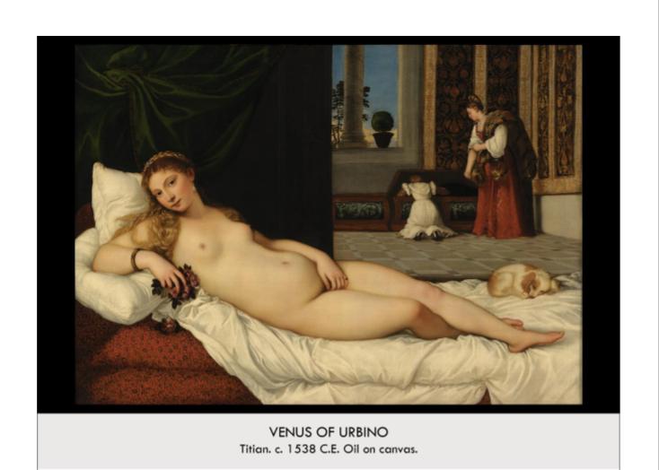

| **Form:** Oil painting on canvas, Layered oil paints to depict the variety of lighting in the painting, Lots of different rich colors to create a sense of contrast, Completed in 1538  **Function:** Pleasure painting for the viewer, The Duke Urbino Guidobaldo II Della Rovere wanted a gift for his new wife and therefore commissioned Titian to paint this , The painting reflected how a wife should be to the husband in a household as a sexual, respectful individual- She also was depicted as a motherly figure for her future children This painting was made to be looked at by many people so Titian made the painting as beautiful as possible  **Content:** A majority of the painting is taken up by a nude female who is known as a Venus, She was named a Venus so that it would be more appropriate to paint her nude, The woman has a direct gaze that meets the eyes of the viewer, Background is equal in color with a darker backdrop on the left and a woman and a child lighter background on the right, The body of the Venus is very different than a real body as the torso of Venus is very large while her feet are very small and unreal, This Venus was a symbol of beauty during the time and that is why she is usually depicted nude, The dog in the background represents fidelity while the child and maid represents motherhood, Uses a wide variety of colors , The painting is very different in style as the lines as the Venus has curves and the rest of the painting is straight lines, Incorporates the Roman time period by using a column and a window that is not using glass and shows that the artist is trying to revert to a style of art that emphasized human beauty, The small tree in the background that looks perfect and ready to grow to represent the future of the marriage, Since the painting has the woman titled Venus it makes the viewer feel more comfortable seeing a nude depiction of a woman  **Context:** The classic western male gaze in art. Made in the guises of Venus. Created during the 16th century. his is an example of perfect Venetian art: The movement of art in Venice was shown with its deep rich colors and use of shadows and use of lights, Glazing techniques were used to create subtle changes in gradient and level, Lots of different colors were available in Venice due to the amount of trade so lots of paintings could be made with a variety of colors, This took place during the 15th century to the end of the 16th century, Venice during this time period was a stable republican government that allowed lots of trade and had the ability to invest in artists, Venice was able to invest in the artwork because of the trading style of the city which generated wealth for the city  **Compare:** Madonna and Child, The David Michelangelo  **80**  Early Europe & Colonial Americas |
| --- |

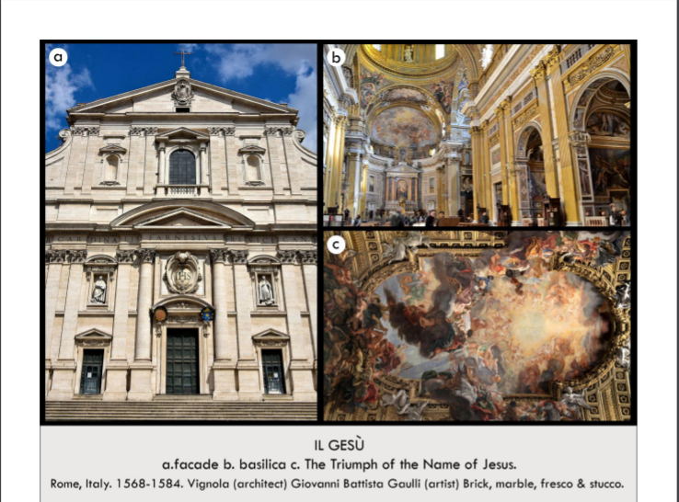

| **Form:** Has a baroque interior. A Gesú, which is simply Italian for the name for the mother church, Church was designed by Giacomo da Vignola and Giacomo Della Porta in 1575, Triumph of the Name of Jesus is a fresco painted in the traditional style, Ceiling fresco done in 1678-1679 by Giovanni Battista Gaulli  **Function:** Serves as the main and original church for the Jesuits- Important place for previous and current Jesuits, as it is the mother church, Also served as a model for the future Jesuit churches in terms of architecture and style. Ceiling fresco serves to illustrate the beliefs of the Jesuits, Called the people to their faith and scared them into not believing  **Content:** The columns are groped and overlap= baroque, corniss is brocken all the way across the front and there is text. There drama comes t the center, a porch to step onto, volutes going up the side, engaged columns. interior : gigantic large space with dome on top and chapels on the side, not renaissance, it is decorated in an opulent fashion, covered in gold, tromploy nature of painting on the ceiling. Single aisled church, removing others as a space for traffic to clear it up, Church has a cruciform floor plan, although the transept is not overly long on either side so it does not bear exactly like a cross in terms of proportions, The church has a dome over the intersection of the large nave and transept, Very dark interior, and it is thus chiefly dependent on natural lighting from outside, An interesting mix of the rational and Baroque styles, Focus on the altar in the center, Renaissance style columns= Corinthian, ornate, and made of rich materials, Some of them reuse ancient pieces, The reusing of ancient materials is called “spolia”  **Context:** During the mannerist period , pointing half way between renaissance are and baroque periods of art. Creating during the mid 1500s. Located in Rome, Italy. Central church of the jesuits( people who go to new world and “education” of natives to become catholic). Saint Ignatius of Loyola, the founder of the newfound Jesuit religion, needed a church to serve as the religion’s center, They were very against the reformation and focused their teachings on charitable works, education, and missionaries, It was then funded by Cardinal Farnese, who was the Pope’s grandson, Church is in the center of old Rome Themes:Religion, spirituality, beliefs and values, War and social conflict, Power and authority, Social concerns/issues, God/religion  **Compare:** Bernini’s Apse at Saint Peter’s Basilica, Michelangelo's Sistine Chapel  **82**  Early Europe & Colonial Americas |
| --- |

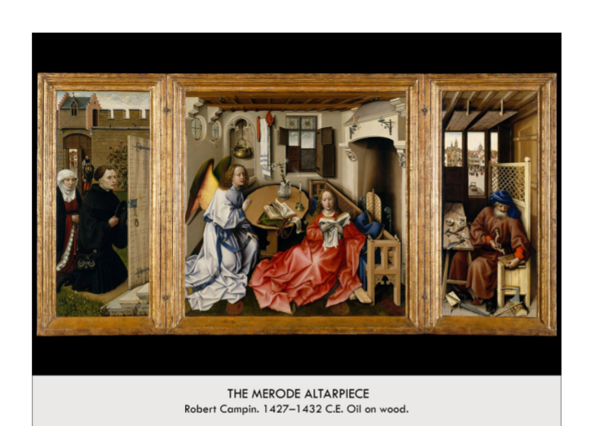

| **Form**: one of the first oil paintings, created of oil on panel, a tryptic, three paintings that go next to each other. Oil on a wood panel placed on a frame which was a private altarpiece for a home. Central scene looks like a living room of someone living in Northern Europe, A lot of detail–– pay attention to everything (Like shiny nails, shadows, rust, Shows age of doors, Even in background (can see men on horseback and a town etc.) Interest in light–– using oil paint so they can paint texture (unlike Italian Renaissance) A lot of realism, yet expressed differently. Space of the room doesn’t make sense because perspective hadn’t really been put into place yet— Not mathematically accurate, The table is a double perspective, Creates a telescoping that brings the viewer in–– makes the room available  **Function:** made as a worship/ decoration for a home, private altarpiece. Can be folded up and carried, Made to maintain an interest–– physical objects to spiritual ideas, To aid in private devotion  **Content:** Center Scene–– Mary and Gabriel- Modern context, Not meant to secularize the scene–– but to make them closer to us and make prayer more intimate, Gabriel just appeared to Mary to tell her she will give birth to Christ, The drapery has sharp folds–– falls on the floor and obscures bodies, The shiny pot represents Mary’s purity, Many things in the room (many have to do with the incarnation), Small figure holding a cross coming through the window heading towards Mary (the holy spirit, one of the first time that God takes human form   * Donors are on the left, The Patrons–– man and his wife, Kneeling–– can recognize them as donors, In a walled garden (hortus conclusus)–– refers to Mary’s virginity * Joseph is on the right, He is making tools in a workshop–– he is a carpenter, Reminds us of how handmade the painting is (it is on wood), Can see prosperous city through window, Mousetrap for sale outside window- Basin and towel= purity, snuffed candle = debated but indicated the holy spirit snuffs the candle flame is gone leaving a body= Jesus lilies= purity father son holy ghost=three buds, mary on the floor shows humility and blacking fireplace=mary keeps you out of hell, mouse traps Jesus snare on the devel   **Context:** During the 15th century, one of the earliest oil paintings made shows the use of paint and shows a lot of detail and realism/naturalism.  **Compare:**  **66**  Early Europe & Colonial Americas |
| --- |

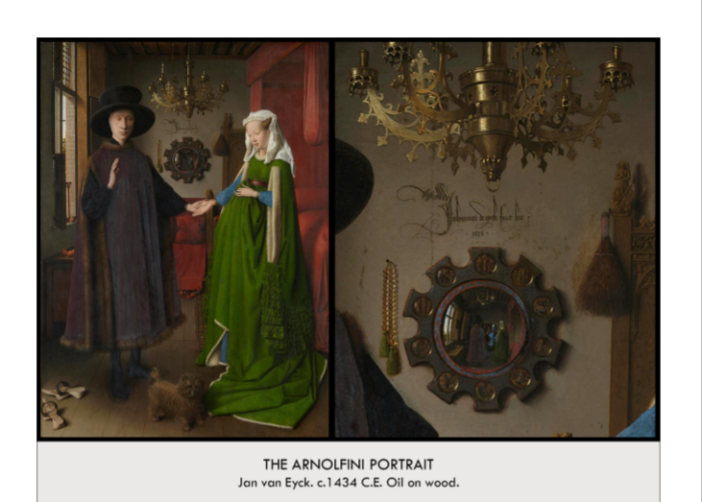

| **Form:** Oil painting on a wood (oak) panel, 34” by 22.5” created by Jan Van Eyck  **Function:** A betrothal painting could be a memorial painting for the wife. Art historians differ in their interpretations of the function of this painting, Documentation of a wedding (why it's sometimes called "The Arnolfini Wedding Portrait"), significant amount of religious imagery, Significance of Van Eyck's signature, Double portrait of an already married couple, Showing off their wealth, Showing off their piety, status as good christians  **Content:** Shows a little dog, standing on holy ground, so have shoes off, she is wearing a very fancy dress and he is wearing a fur lined robe= very expensive clothes and fruits on the plate, there is a whisk which is the symbol of work and there a mirror showing a mirrored image and there was a portrait of the artist with his name and the date. Wife pulling up the dress t represent childbirth- clothes are dead animals. Light on his face, just hitting the eye.  Portrait of a husband and wife, Possibly Giovanni Arnolfini (?), definitely a wealthy merchant who worked in Bruges, prosperous economic town in the 15th century. wearing furs, heavy clothing, despite warm weather, wife is wearing gathered skirt to make her appear pregnant. Surrounded by token symbols of their life that give evidence of what may be happening, dog= a symbol of fidelity, oranges=had to be imported, expensive, ritch. significant amount of religious imagery, candle in chandelier (God's presence), prayer beads on the wall, next to the mirror, roundels on the mirror show biblical scenes, light streaming in from window shows Van Eyck's mastery of light and shadow, soft texture  **Context:** Painting from the northern renaissance, a domestic portrait of a newly marries couple, symbols of their good life, their life together, on the back is on the back and is signed by the artist. 15th century. gives an ultimate form of realism. First great master of oil paint. Shows that artist have the same capacity for edvantion. He was a painted from baroque ideas. Both Northern Renaissance and Italian Renaissance are concerned with realism, but in different ways, Northern lacks perspective and obsession with human anatomy, but boasts greater attention to minute detail and softer gradations of color and light because of GLAZING, layer upon layer of translucent oil paint, creates softer colors, more realistic because translucent and smooth blending and gradations, the Italian painters still used tempera and fresco. The size of the detailed roundels (half a fingernail!) shows mastery of fine detail in even the smallest of scenes, The dog's hair and the texture of the wife's gown/coat/cape are also great examples of this fine detail and texture  **Compare:**  **68**  Early Europe & Colonial Americas |
| --- |

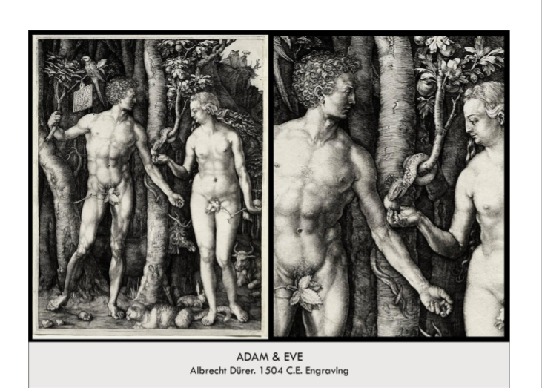

| **Form:**  Engraving. On copper incised with a small knife and crosshatched with engraving. Northern artist taking on a souther themes, he is showing an ideal version of Adam and Eve with perfect bodies.  **Function:**  As a print to be sold to the people, depiction of a scene from the bible.  **Content:**  Intention to detail, adam and eve in idea proportions (italian/ ancient greece) painting full of symbolism the oxe,(phlegmatic, lethargic and lazy) rabbit( energetic- sanguin),cat(color- excess of anger) elf( melancholy/sadness) 4 bodily humors, medieval medicine says your body is balanced by there 4 things. Shows the biblical story of devel giving the apple to eve and they she giving it to adam, the mouse represents satin.  **Context:**  Created after he returned from italy. He was the first widely plagiarized artist. So he put his signature and monogram to sign his work. FIrst contemporary moder artist who widely sold to the public. He is a humanist. Italian ideas in a norther work, Durer was an artist from germany. He was a humanist. Was a famous master of printmaking  **Compare: Dorophorise**  **74**  Early Europe & Colonial Americas |
| --- |

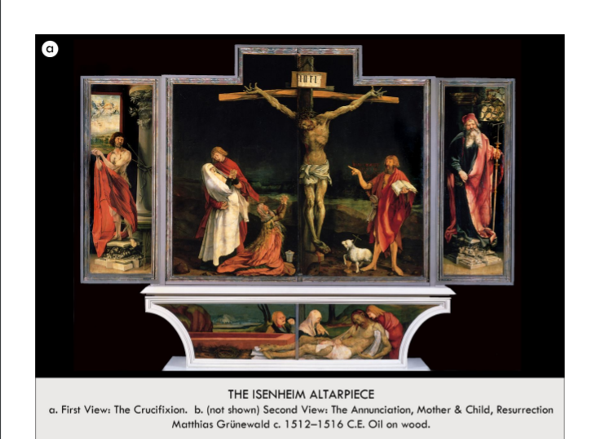

| **Form:** Is the closed part of the alter piece. Created by Matthias Grünewald. Oil on wood located in Christian, German. Germany (now in France)  **Function:**Created for people who were dying. Created to serve as the central object of devotion in an Isenheim hospital built by the Brothers of St. Anthony, Popular in Germany at the time  Facilitate public prayer. Fully opened on special occasions → helps to inspire hope  **Content:** Left picture: panels is **closed,** Virgin is swooning into the arms of St. John the Evangelist, John the Baptist gestures towards Christ, Lamb of God is below him (metaphor for Christ himself)= not usually at crucifixion. Inclusion is symbolic, since he is considered as the last of the prophets to announce the coming of the Messiah, Mary Magdalene is just crying, Outside panels: St. Sebastian and then the St. Anthony Abbott  Depicts a gruesome scene on and we see christ on the cross, during the crucifixion, and there is such pain and agony in mangled crist, and many is on the left being held by john shows as distraught in a half gothic and half renaissance art. On the prodella(bottom) shows jesus down from the cross who is shows with lesserady ( skin diseases) to shows the people at the hospital they are not alone.  **Context:** Isenheim Hospital was run by Brothers of St. Anthony, St. Anthony was a patron saint of those suffering from skin diseases, Took care of sick and dying peasants at hospital. Christ was painted in such a macabre way to show them that he too suffered like they are now. Predella: the bottom part in the altarpieces  **Compare:**  **77**  Early Europe & Colonial Americas |
| --- |

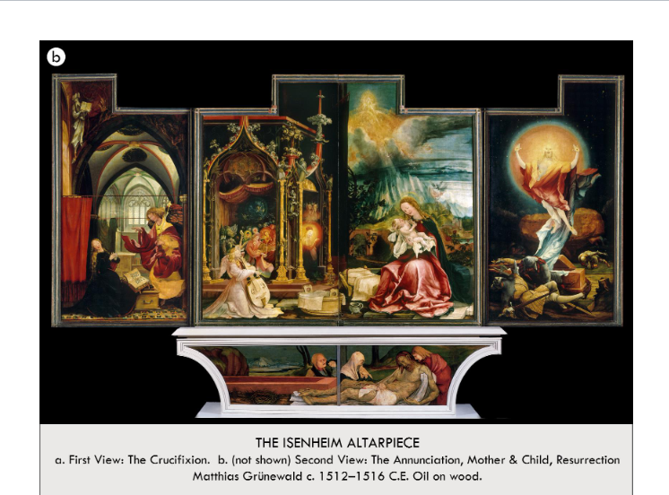

| **Form:**  **Function:**  **Content:**  Annunciation on the left and angles towards mary, show the holy spirit looking as a beautiful and tender many holding a baby face jesus and of the right is a radiant jesus who is emerging from the tomb and being reborn. Right picture: panels are **open.** From left to right: Annunciation, Virgin and Child, Resurrection, Angels playing music celebrate the birth of the Christ child, resurrection (fireball— hovering over the sepulchre and the bodies of the sleeping soldiers, a combination of Transfiguration, Resurrection and Ascension.). Both predellas show a Lamentation scene  **Context:**  When opened the scenes are hopeful and show a beautiful image  **Compare:**  **77**  Early Europe & Colonial Americas |
| --- |

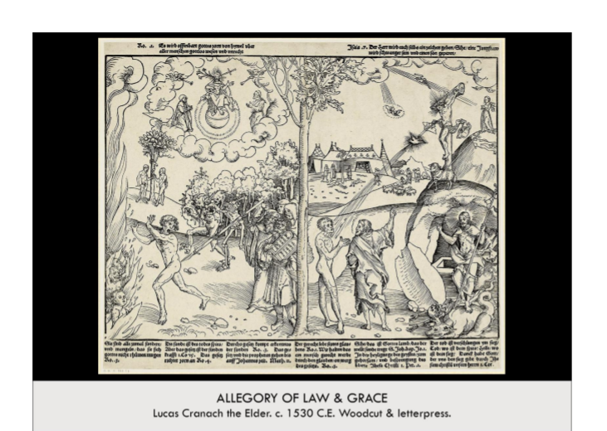n

| **Form:** Woodcut print on paper that was reproduced widely and distributed, woodcut is taking a piece of limewood and cut away all the pieces that will turn light, very graphic linier form. Material/technique → woodcut and letterpress. Lucas Cranach the Elder = artist, Located in Germany. Northern Renaissance  **Function:**Prodestent reformation, church propaganda for the prodestent faith. *The Law and the Grace* explains luther’s ideas in visual form. Heaven is reached through faith and god’s grace. Luther despised and rejected the Catholic idea that good deeds (“good works”) could play any role in salvation  Catholics Vs. Luther: how to get to heaven? Catholics= Believer could take action to vouchsafe their salvation by good deed (financial donations and paying for art)  Luther= Insisted that salvation was in God’s hands and all the believer had to do was to open up and have faith. Anger led to rebellion and destruction of artwork that the Catholic Church was become rich on  **Content:** Left the worldview of the catholics is being shows an dtheta they church has to be with you, and shows adam and eve and on the right is the prodestent world view where you have a direct relation to chris( prey in head and talking to god) Jesus died on cross and this right came to you, they simplified all of that stuff.  **Context:** Created in the 16th century in france and was used to support the prodestance. And if was a time of printmaking so more people had access to read their own bibles and separate from the church a little. Destruction of thousands of works of religious art. Iconoclasts stormed through churches.“How did heaven get to be so controversial?” *The Law and the Grace=* Single most influential image of the **Lutheran Reformation.** The Reformation––initiated by Martin Luther in 1517 (attempt to reform the Catholic Church, which had been the only church in western Europe up until Luther)  **Compare:** Catacomb of Priscilla  **79**  Early Europe & Colonial Americas |
| --- |

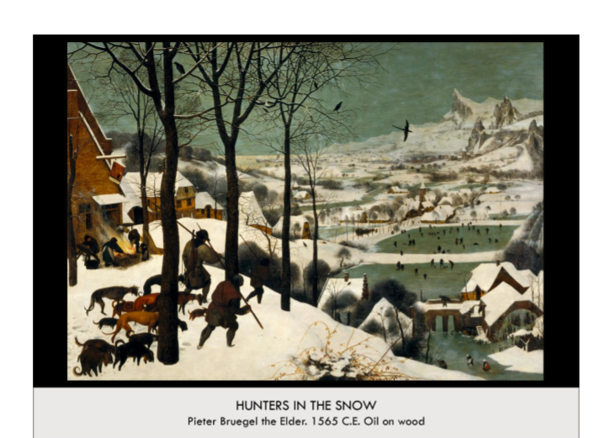

| **Form:** Oil paint on canvas. Painted by Pieter Bruegel in 1565, Oil Paint on Wood Panel, Realist Period, Vienna, Austria. 117 cm by 162 cm, Contrapposto, dynamic movement, Figures with their back towards the viewer -- draws eye into the scene, away from the foreground, Lots of contrasting colors -- draws eye around the composition, Sharp forms, less gentle blending.Very, very subtle use of atmospheric perspective in the back-most mountains and hills  **Function:** A painting created as one of a series of 6 displaying the season representing 2 mouther each. It was a commission for a wealthy client. Represents both the hardships and the enjoyments of winter, Sheds light on the activities of everyday life, Reaction to the renaissance themes of nobility and religion, Making art to depict the world as it is seen  **Content:** A group of 2 hunters returning with hunting dogs, and returning with one fox, they are passing by and inn which outside people are gathered by a fire and in the background there are people ice skating and people are playing games, there are carts down the streets with houses churches and trees, there are a group of ravens flying u top. Foliage in the foreground coming out of the ground. Part of a six-part series of images called seasons of the year. There are Figures, and houses painted in warm, earthy tones -- contrasting from the cold blues and grays used to represent the elements. Homogenized figures, none of which show their face--represent the poor, “nameless”. Hunters return from what might have been an unsuccessful hunt- Both figures and dogs bend down and sulk, looking exhausted, Small figures in the background dot a pair of frozen lakes, seemingly enjoying the winter, Figures dance about the ice, interacting with each other and small objects. Mood in the foreground -- solemn, sense of despair, Figures in bottom left third sag, trudging through the snow, Left-most figures huddle by the fire, desperate for warmth, Almost every visible figure has a downward gaze. Architecture -- where nature and civilization meet, Rows of houses fall away into vast fields of snow. The viewers eyes are drawn across the painting diagonally by the positioning of the subjects and statically placed lines, No linear perspective! Aerial Perspective! We start at the bottom right as these figures are largest and appear closest to the viewer, Our eyes instantly shift onto the frozen pond were the peasants appear to be enjoying the winter, The immediate shift between the hunters and the other peasants indicate that Bruegel wanted to contrast these two groups of people, These figures appear to be playing a version of hockey and ice skating and do not have the give of the same negative feelings that the hunters do, As our eyes continue along, we see a village in the background on the left, It is pretty empty and probably is meant to keep the viewers eyes on pond, moving up into the mountainsThe birds are also pointed at the pond and help focus our eyes on the subjects  **Context:** Invents idea of seasons painting, best winter scenes. One of the first people to paint just normal people with dignity. Painting has a wonderful structure. With interlocking diagonals. Most unique or norther artist, true northern no italian work. Bruegel is best known for his landscapes and his focusing on the life and mannerisms of peasants- this is fitting considering the content of this work, It was commissioned by Nicaels Jonghelinck. This is a secular painting(no Jesus), This is one of six works in series entitled Months of the Year. Northern Renaissance, This probably depicts a scene somewhere in the alps This is because Holland is an extremely flat country, yet there are mountains in the background.  **Compare:**  Bayueax Tapestry, Seated Boxer  **83**  Early Europe & Colonial Americas |
| --- |